Project Synopsis

on

**SecureVote**

Submitted as a part of course curriculum for

**Bachelor of Technology**

in

**Computer Science**



**Submitted by**

Rhythm Garg (2100290120141)

Aashish Gupta (2100290120001)

**Under the Supervision of**

Mrs. Arti Sharma

**KIET Group of Institutions, Ghaziabad**

**Department of Computer Science**

**Dr. A.P.J. Abdul Kalam Technical University**

**2022-2023**

**ACKNOWLEDGEMENT**

It gives us a great sense of pleasure to present the synopsis of the B. Tech Mini Project undertaken during B.Tech. Third Year. We owe a special debt of gratitude to Mrs Arti Sharma, Department of Computer Science, KIET Group of Institutions, Delhi- NCR, Ghaziabad, for her constant support and guidance throughout the course of our work. Her sincerity, thoroughness and perseverance have been a constant source of inspiration for us. It is only her cognizant efforts that our endeavours have seen the light of the day.

We also take the opportunity to acknowledge the contribution of Dr. Ajay Kumar Shrivastava, Head of the Department of Computer Science, KIET Group of Institutions, Delhi- NCR, Ghaziabad, for his full support and assistance during the development of the project. We also do not like to miss the opportunity to acknowledge the contribution of all the faculty members of the department for their kind assistance and cooperation during the development of our project.

Last but not the least, we acknowledge our friends for their contribution to the completion of the project.

Signature: Guide Name & Signature

Student’s Name: Rhythm Garg, Aashish Gupta

Roll No: 2100290120141, 2100290120001

**ABSTRACT**

Secure Vote presents a groundbreaking solution poised to transform the electoral landscape, particularly in India, by harnessing the power of blockchain technology. This innovative platform amalgamates the core principles of transparency, immutability, and security to safeguard the integrity of each vote. In a nation grappling with various electoral challenges, Secure Vote emerges as a beacon of hope, offering tangible solutions to pervasive issues.

One of the primary concerns plaguing the current electoral system in India is the rampant proliferation of fake and illegal voter identity cards. This undermines the very foundation of democracy by diluting the legitimacy of election outcomes. Furthermore, the susceptibility of Electronic Voting Machines (EVMs) to tampering and hacking poses a significant threat to the sanctity of the electoral process, casting doubt on the fairness and accuracy of results. Moreover, the system suffers from low voter participation rates, indicating a disenchantment with the existing mechanisms and a need for reform. Additionally, the exorbitant financial burden placed on taxpayers to maintain and manage the electoral infrastructure further exacerbates the inefficiencies of the system.

Secure Vote stands as a beacon of change, offering a decentralized and secure alternative that addresses these pressing concerns head-on. By providing a transparent and immutable ledger of votes, Secure Vote ensures that every ballot is accounted for and protected from tampering. This not only enhances the credibility of election outcomes but also fosters greater trust among citizens in the democratic process. Moreover, by streamlining operations and reducing the reliance on costly infrastructure, Secure Vote promises to alleviate the financial strain on taxpayers while promoting greater inclusivity and participation in elections. Through its innovative approach, Secure Vote represents a pivotal step towards revitalizing democracy in India and beyond.

**TABLE OF CONTENTS**

|  |  |
| --- | --- |
|  | Page No. |
| TITLE PAGE .................................................................................................................... |  |
| ACKNOWLEDGEMENT.................................................................................................. |  |
| ABSTRACT...................................................................................................................... |  |
|  |  |
| CHAPTER 1 INTRODUCTION |  |
| 1.1.          Introduction ……………………................................................... |  |
| 1.2 Problem Statement.……………………....................................... |  |
| 1.3.          Objective………………………………………………………… |  |
|  |  |
| CHAPTER 3  PROPOSED METHODOLOGY …………………………………........ |  |
| 3.1 Flowchart |  |
|  |  |
| CHAPTER 4 TECHNOLOGY USED ………..………………………..………………. |  |
| CHAPTER 5 ER DIAGRAM .......................................................................................... |  |
| CHAPTER 6 CONCLUSION …....................................................................................... |  |
|  |  |
|  |  |
|  |  |
|  |  |

**INTRODUCTION**

Introducing Secure Vote: an innovative solution poised to revolutionize the electoral process. This groundbreaking Blockchain-based system integrates the core principles of transparency, immutability, and security to safeguard the integrity of every vote casted. In a world where electoral systems face mounting challenges, Secure Vote emerges as a beacon of change, offering tangible solutions to address persistent issues. By leveraging the inherent strengths of blockchain technology, Secure Vote aims to restore trust and confidence in the democratic process. With its transparent and immutable ledger, Secure Vote ensures that each ballot is accurately recorded and protected against tampering or manipulation. Through its commitment to integrity and security, Secure Vote heralds a new era of electoral accountability and inclusivity, empowering citizens to participate in shaping the future of governance with confidence and transparency.

**PROBLEM STATEMENT**

The current electoral framework in India is besieged by a multitude of challenges that erode the efficacy and credibility of elections. Chief among these challenges is the pervasive issue of counterfeit and unlawful voter identity card registrations, which not only dilute the integrity of the voting process but also cast doubt on the legitimacy of electoral outcomes. Moreover, the vulnerability of Electronic Voting Machines (EVMs) to tampering and hacking poses a grave threat to the sanctity and accuracy of the voting process, potentially undermining the very essence of democracy.

Furthermore, the persistently low levels of voter participation signal a broader disenchantment with the electoral system, reflecting a lack of trust and engagement among citizens. Additionally, the excessive financial burden placed on taxpayers to maintain and administer the electoral infrastructure exacerbates the inefficiencies of the system, diverting resources that could be better utilized elsewhere. These multifaceted challenges collectively hinder the democratic process in India, necessitating urgent and comprehensive reforms to ensure fair, transparent, and inclusive elections.

**OBJECTIVES**

Open Verifiability and Transparency: It is imperative that the election system provides mechanisms for open verifiability and transparency, allowing stakeholders to scrutinize and verify the integrity of the electoral process. This entails establishing accessible channels through which citizens, election officials, and independent observers can review and authenticate the entire voting process, from voter registration to ballot counting. By ensuring transparency, the system fosters trust and confidence among voters, assuring them that their voices are accurately represented and their rights upheld within the democratic framework.

Integrity and Non-Manipulation: Central to the credibility of any election system is the assurance that votes cast by voters remain unaltered and free from manipulation. The election system must employ robust cryptographic techniques and secure protocols to safeguard the integrity of each vote, preventing unauthorized tampering or alteration. Through end-to-end verifiable mechanisms, voters can verify that their ballots have been accurately recorded and counted as per their intentions, without any interference or manipulation by external actors. Upholding the principle of non-manipulation not only preserves the sanctity of the democratic process but also reinforces the trustworthiness of the electoral system, ensuring that election outcomes accurately reflect the will of the electorate.

**METHODOLOGY**

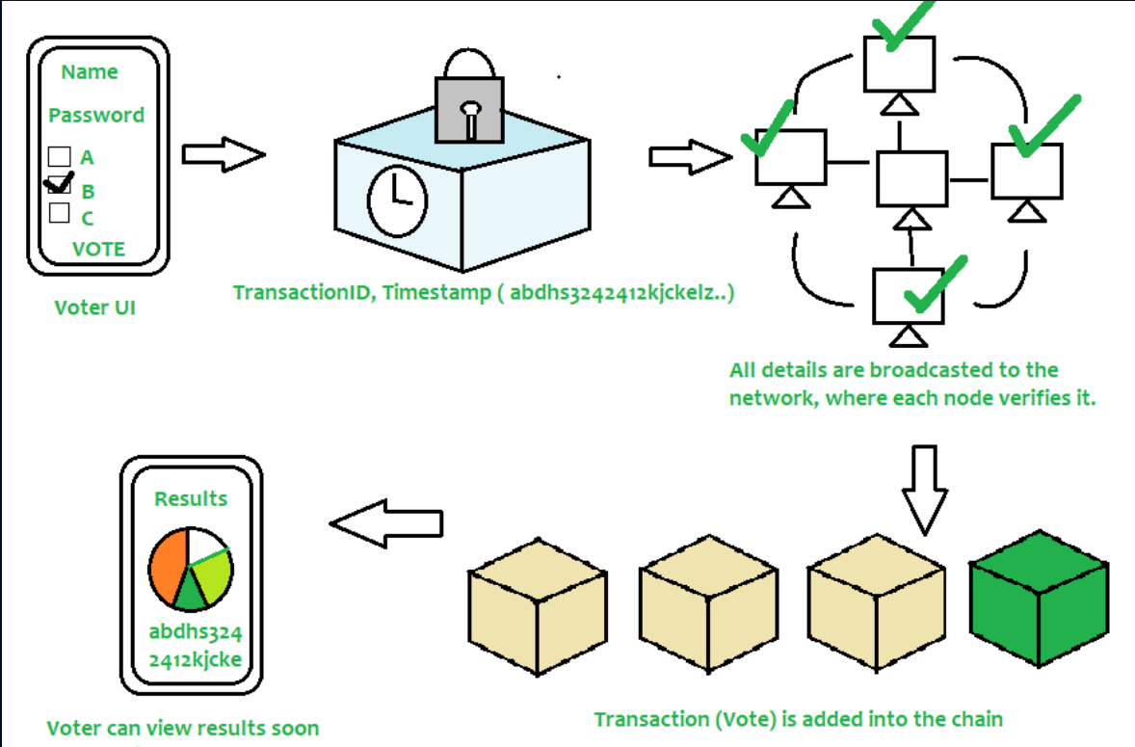

**TECH STACK USED**

* Solidity
* React.js
* Node.js
* Hardhat
* Ether.js
* Remix IDE

**ER DIAGRAM**

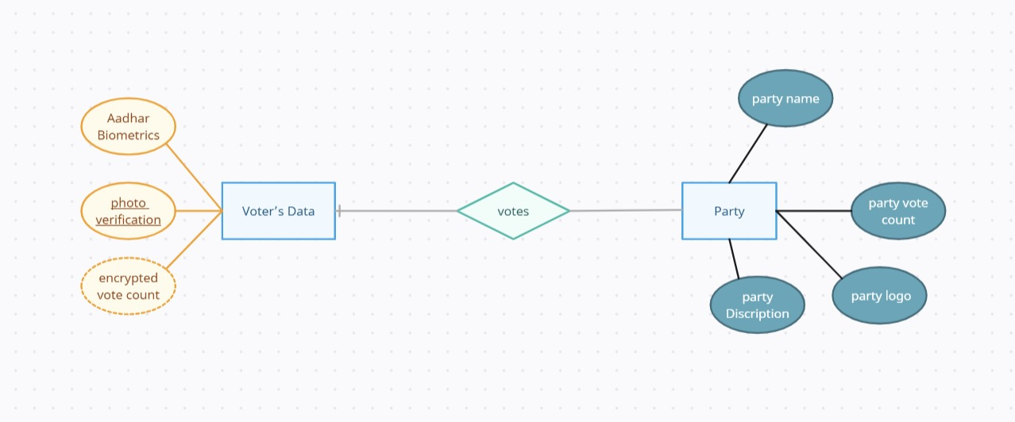

**CONCLUSION**

In conclusion, Secure Vote presents a holistic solution that addresses critical imperatives of security, participation, and transparency in the electoral process. By leveraging blockchain technology, Secure Vote ensures the highest standards of security, safeguarding the integrity of each vote against tampering or manipulation. Furthermore, its decentralized architecture fosters greater participation by providing accessible and inclusive voting mechanisms, empowering citizens to engage in the democratic process with confidence. Moreover, Secure Vote upholds transparency as a fundamental principle, enabling stakeholders to openly verify and authenticate the entirety of the voting process. Through its commitment to these three paramount parameters, Secure Vote not only revolutionizes the electoral landscape but also reinforces the foundational pillars of democracy, laying the groundwork for a more resilient, inclusive, and trustworthy electoral framework for the future.